SIMATS ENGINEERING
ASSESSMENT TOOL 3: Application Based Questions

COURSE NAME: | Cloud Computing and Big Data Analytics | COURSE CODE: | CSA1506

COURSE OUTCOME COVERED
CO2: Analyze virtualization architectures to identify performance and security issues in cloud computing environments. (BL3)
Assessment Tool Weightage: 10%

Dave's Taxonomy: Manipulation (Level 2)  Question Count: 5 | Total Marks: 25

Code of Conduct
I Lokesh S (192511037) (Name / Reg No) certify that this submission is my original work and that I have adhered to the guidelines specified for this assessment.
I understand that any violation of academic integrity rules will result in disciplinary action.
Signature of the student: ____________________

Assessment Tasks

Application Based Questions

- A company experiences unpredictable traffic spikes during seasonal sales. Explain how cloud auto-scaling and load balancing can handle this demand efficiently. How does this approach reduce downtime and improve user experience? What role do monitoring tools play in this setup? Relate your answer to a real-world e-commerce scenario.

- An organization wants to store large volumes of backup data securely in the cloud.
Discuss how cloud storage solutions ensure durability and data redundancy.
How can encryption and access control protect sensitive backup data?
Explain the cost advantages compared to traditional storage systems.
Provide an example of a disaster recovery use case.
- A mobile app company plans to deploy its application globally. Explain how content delivery networks (CDNs) improve performance and reduce latency. How do edge servers enhance user experience across regions? Discuss how cloud providers support global availability. Relate this to a real-time streaming or gaming application.

- A financial institution requires strict compliance and data security in cloud usage.
Explain how cloud providers support regulatory compliance and auditing. What role do logging, monitoring, and encryption play in security? How can the company ensure data sovereignty requirements are met? Give an example involving sensitive financial transactions.
- A development team wants to adopt containerization for application deployment.
Explain how containers differ from virtual machines in terms of performance and resource usage. How does orchestration (like Kubernetes) simplify deployment and scaling? Discuss portability benefits across different cloud environments.
Provide an example of a microservices-based application.

Application Based Questions Rubric
Criteria | Weightage | Level 4 - Exemplary | Level 3 - Proficient | Level 2 - Developing | Level 1 - Beginning
Relevance to Application | 25% | Response directly addresses the given use case with strong relevance | Mostly relevant response | Partially relevant | Weak relevance
Use of Cloud Concepts | 25% | Applies appropriate concepts accurately | Mostly accurate application | Basic application only | Incorrect concept usage
Practical Insight | 20% | Shows strong real-world understanding | Shows reasonable practical understanding | Limited practical insight | No practical insight
Completeness | 15% | Response covers all required aspects | Covers most aspects | Covers only basic aspects | Incomplete response
Clarity | 15% | Clear and concise answer | Generally clear | Some confusion in expression | Poor clarity

1.A company experiences unpredictable traffic spikes during seasonal sales. Explain how cloud auto-scaling and load balancing can handle this demand efficiently. How does this approach reduce downtime and improve user experience? What role do monitoring tools play in this setup? Relate your answer to a real-world e-commerce scenario.
Answer
Architecture Diagram
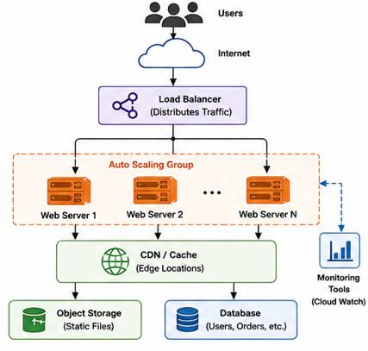
Explanation
During seasonal sales, an e-commerce company experiences a sudden increase in customer traffic. Cloud platforms use Load Balancing and Auto-Scaling to ensure the application remains available and performs efficiently.
Load Balancing distributes incoming user requests evenly among multiple web servers. This prevents any single server from becoming overloaded and ensures all servers share the workload. If one server fails, traffic is automatically redirected to healthy servers, reducing downtime.
Auto-Scaling continuously monitors resource usage such as CPU utilization, memory usage, and network traffic. When demand increases, additional virtual machines or instances are automatically launched. Once traffic decreases, unnecessary instances are removed, reducing infrastructure costs.
Role of Monitoring Tools
Cloud monitoring services continuously collect performance metrics such as CPU usage, response time, memory utilization, and network traffic. When predefined thresholds are exceeded, alerts are generated, and auto-scaling policies are triggered automatically. Monitoring also helps administrators identify performance bottlenecks and maintain system health.
Benefits
- Handles sudden traffic spikes efficiently.
- Minimizes downtime through automatic scaling and failover.
- Improves application response time and user experience.
- Optimizes cloud costs by using resources only when needed.
- Ensures high availability during peak business periods.
Real-World Example
During the Amazon Great Indian Festival or Flipkart Big Billion Days, millions of customers access the websites simultaneously. Cloud load balancers distribute customer requests across multiple servers, while auto-scaling automatically launches additional instances to handle increased traffic. Monitoring tools continuously track system performance and trigger scaling when required. This ensures customers can browse products, place orders, and complete payments without delays or website crashes.
Conclusion
By combining Load Balancing, Auto-Scaling, and Monitoring Tools, cloud platforms can efficiently handle unpredictable traffic spikes, reduce downtime, improve user experience, and provide reliable services during high-demand events such as seasonal online sales.

2.An organization wants to store large volumes of backup data securely in the cloud. Discuss how cloud storage solutions ensure durability and data redundancy. How can encryption and access control protect sensitive backup data? Explain the cost advantages compared to traditional storage systems. Provide an example of a disaster recovery use case.
Answer
Architecture Diagram
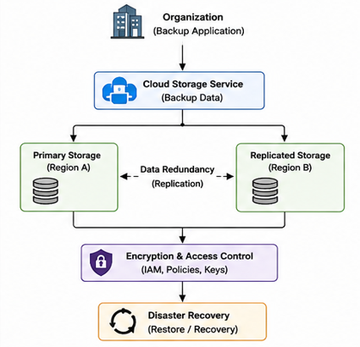
Explanation
Cloud storage is an efficient solution for storing large volumes of backup data because it provides high durability, data redundancy, security, and scalability. Backup data is stored across multiple storage devices and different geographic locations, ensuring that data remains available even if one server or data center fails.
Data durability is achieved by storing multiple copies of backup data across different storage systems. Data redundancy ensures that if one copy is lost due to hardware failure or disaster, another copy can be used for recovery. Many cloud providers also use automatic replication to maintain backup copies in different regions.
Encryption and Access Control
Sensitive backup data is protected using encryption and access control mechanisms. Encryption converts data into an unreadable format during storage and transmission, ensuring that only authorized users with the correct decryption key can access it. Role-Based Access Control (RBAC) and Multi-Factor Authentication (MFA) restrict access to authorized users and prevent unauthorized modifications or data theft.
Cost Advantages
Compared to traditional storage systems, cloud storage offers several cost benefits:
- No need to purchase and maintain expensive storage hardware.
- Pay only for the storage capacity used (pay-as-you-go model).
- Easy scalability without additional infrastructure investment.
- Reduced maintenance and operational costs since the cloud provider manages the storage infrastructure.
Disaster Recovery Example
Consider a company whose primary data center is damaged due to a fire or flood. Since backup data is replicated to another cloud region, the organization can quickly restore its applications and databases from the replicated backup. This minimizes downtime and ensures business continuity without significant data loss.
Conclusion
Cloud storage provides high durability, data redundancy, encryption, and secure access control, making it an ideal solution for storing backup data. Combined with replication and disaster recovery mechanisms, it ensures data availability, reduces operational costs, and enables organizations to recover quickly from unexpected failures.

3.A mobile app company plans to deploy its application globally. Explain how Content Delivery Networks (CDNs) improve performance and reduce latency. How do edge servers enhance user experience across regions? Discuss how cloud providers support global availability. Relate this to a real-time streaming or gaming application.
Answer
Architecture Diagram
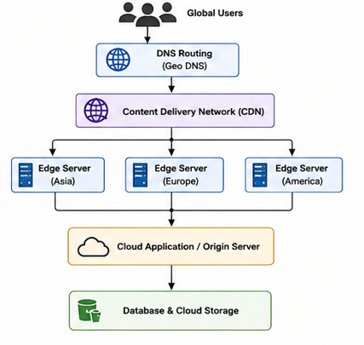
Explanation
A Content Delivery Network (CDN) is a distributed network of edge servers located in different geographic regions. Instead of serving all user requests from a single central server, the CDN delivers content from the nearest edge server. This significantly reduces latency, improves application performance, and provides faster access to users worldwide.
Role of Edge Servers
Edge servers store cached copies of frequently accessed content such as images, videos, application files, and game assets. When a user requests content, it is delivered from the nearest edge server instead of the origin server. This reduces network congestion, decreases response time, minimizes buffering, and provides a smooth user experience regardless of the user's location.
Global Availability
Cloud providers maintain multiple data centers across different regions and integrate them with CDN services. If one region experiences a failure, user requests are automatically redirected to another available region, ensuring continuous service availability. Load balancing and automatic replication further improve reliability and fault tolerance for global applications.
Real-World Example
A real-time streaming platform such as Netflix or a multiplayer gaming platform like PUBG Mobile serves millions of users worldwide. Videos, game updates, and static content are cached on CDN edge servers located in different countries. When users access the application, content is delivered from the nearest edge server, resulting in faster loading times, reduced buffering, and lower latency during gameplay or video streaming.
Conclusion
A Content Delivery Network (CDN) improves global application performance by distributing content through edge servers located close to users. Combined with the global infrastructure provided by cloud providers, CDNs reduce latency, improve availability, enhance user experience, and ensure reliable performance for real-time streaming and gaming applications.

4.A financial institution requires strict compliance and data security in cloud usage. Explain how cloud providers support regulatory compliance and auditing. What role do logging, monitoring, and encryption play in security? How can the company ensure data sovereignty requirements are met? Give an example involving sensitive financial transactions.
Answer
Architecture Diagram
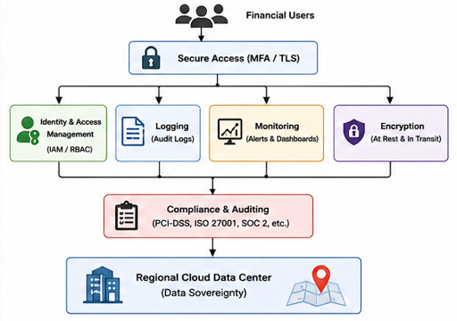
Explanation
Financial institutions deal with highly sensitive customer information such as account details, payment records, and transaction history. Cloud providers support regulatory compliance by following industry standards such as ISO 27001, PCI-DSS, SOC 2, and GDPR. They also provide auditing tools that record user activities, system changes, and security events, helping organizations demonstrate compliance during security audits.
Role of Logging, Monitoring, and Encryption
Logging records every user login, transaction, and administrative action performed in the cloud. These logs help detect unauthorized access and provide evidence during security investigations.
Monitoring continuously tracks system performance, user activities, and security threats. If unusual behavior such as repeated login failures or suspicious transactions is detected, alerts are sent to administrators for immediate action.
Encryption protects sensitive financial data both at rest and in transit. Data stored in cloud databases is encrypted using algorithms such as AES-256, while communication between users and cloud services is protected using TLS/SSL. This ensures that even if data is intercepted, it cannot be read without the encryption keys.
Ensuring Data Sovereignty
To meet data sovereignty requirements, the financial institution should store customer data only in cloud data centers located within the country or region where regulations require it. Cloud providers allow organizations to choose specific geographic regions for storing and processing data. Access policies and encryption keys should also remain within the same region to comply with legal and regulatory requirements.
Example
Consider an online banking system where customers transfer money between accounts. Every transaction is encrypted before transmission, recorded in audit logs, and continuously monitored for suspicious activities. Customer data is stored only in approved regional data centers to comply with national banking regulations. If any unauthorized transaction is detected, monitoring systems immediately alert security administrators for investigation.
Conclusion
Cloud providers support secure financial operations through regulatory compliance, auditing, logging, monitoring, encryption, and regional data storage. These features help financial institutions protect sensitive customer information, meet legal requirements, and ensure secure and reliable financial transactions in the cloud.

5.A development team wants to adopt containerization for application deployment. Explain how containers differ from virtual machines in terms of performance and resource usage. How does orchestration (like Kubernetes) simplify deployment and scaling? Discuss portability benefits across different cloud environments. Provide an example of a microservices-based application.
Answer
Architecture Diagram
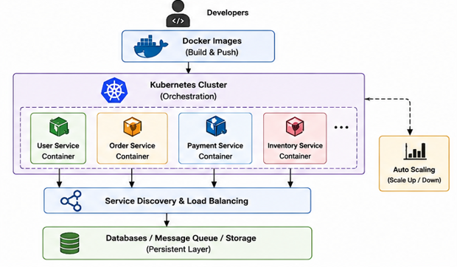
Explanation
Containers package an application along with its dependencies, libraries, and configuration files into a lightweight unit. Unlike Virtual Machines (VMs), containers share the host operating system kernel, making them faster and more efficient.
Containers vs Virtual Machines
Containers | Virtual Machines
Share the host OS kernel | Each VM has its own operating system
Lightweight | Heavyweight
Faster startup (seconds) | Slower startup (minutes)
Lower CPU and memory usage | Higher resource consumption
High application density | Fewer VMs per server
Because containers do not require a separate operating system for each instance, they consume fewer resources and provide better performance than virtual machines.
Role of Kubernetes in Deployment and Scaling
Kubernetes is a container orchestration platform that automates the deployment, management, and scaling of containers. It continuously monitors container health and automatically restarts failed containers. During high user traffic, Kubernetes increases the number of container instances using auto-scaling. When demand decreases, it removes unnecessary containers, ensuring efficient resource utilization. It also provides load balancing by distributing requests evenly among running containers.
Portability Across Cloud Environments
Containers can run consistently on any cloud platform because they package the application with all required dependencies. Whether deployed on AWS, Microsoft Azure, Google Cloud Platform (GCP), or an on-premises server, the application behaves the same. This portability reduces vendor lock-in and simplifies migration between cloud providers.
Example of a Microservices-Based Application
An online shopping application can be built using microservices where each service performs a specific function:
- User Service – Manages user accounts and authentication.
- Product Service – Handles product catalog and inventory.
- Order Service – Processes customer orders.
- Payment Service – Handles online payments.
Each service runs in its own container and is managed by Kubernetes. If the Payment Service experiences high traffic, Kubernetes automatically scales only that service without affecting the others.
Conclusion
Containerization provides better performance, lower resource usage, and faster deployment compared to virtual machines. Kubernetes simplifies container management through automated deployment, scaling, load balancing, and fault recovery. Combined with the portability of containers, it enables organizations to build scalable and reliable microservices-based applications that can run seamlessly across different cloud environments.

